Bachelor of Computer System and Information Technology
Pokhara College of Management
Pokhara Metropolitan City-3, Gyanmarg, Nadipur ,Kaski


Final Project Report
ON
SkillBridge – Student Skill Exchange Platform

Submitted by : Submitted to:
Group Members: Mr.Indra Oli
1. Bikram Poudel
2. Srijana Adhikari Pokhara College of Management
3. Swostika Adhikari
Semester: 2nd semester

ACKNOWLEDGEMENT
This document is an expression of appreciation to our supervisor for oversight and direction during the development of our project.
This project could not have been completed without the use of facilities, resources, and the learning environment provided by the other faculty and administration at college.
Additionally, we would like to extend our appreciation to the team for the dedication to the project and to the collaborative effort that helped the team complete the SkillBridge project.
Finally, we would like to thank our classmates and friends for providing suggestions and input through-out the design and development of the project.

ABSTRACT
SkillBridge connects students interested in exchanging knowledge through a collaborative, peer-to-peer learning environment where students can connect with potential mentors, find out about them, and schedule learning sessions based on their interests and goals. The goal of this project was to provide solutions to issues such as high costs of online learning platforms; limited number of available mentors; and no community-based student-centered learning environment. The project's focus was on delivering a simplistic, contemporary, and user-friendly end user experience based on UI/UX design principles. The final deliverables are comprised of a complete UI/UX design; a fully functional website containing the following pages; Home, Explore Skills, Mentor Profile, Chat/Book and Dashboard.

Table of Contents
ACKNOWLEDGEMENT 2
ABSTRACT 3
1. Introduction 6
1.1 Problem Statement 6
1.2 Project as a Solution 6
1.3 Aim 7
1.4 Objectives 7
2. BACKGROUND 8
2.1 About the End User 8
Table 1: Target User Groups 8
2.2 Understanding the Solution 9
2.3 Current Projects 9
Table 2: Comparison of Similar Platforms 10
3. DEVELOPMENT 10
3.1 UI/UX Design 10
Figure 1: Home Page Design 11
Figure 2: Explore Skills Page 12
Figure 3: Mentor Profile Page 12
Figure 4: Chat and Booking Page 13
Figure 5: Dashboard 13
3.2 Implementation 14
Table 3: Color Palette 14
Table 4: Typography 14
3.3 Testing and Analysis 15
4. Tools and Technologies 15
4.1 Figma 16
4.2 HTML 16
4.3 CSS 16
4.4 JavaScript 16
4.5 Tailwind CSS 16
4.6 React.js 16
5. CONCLUSION 16
5.1 Limitations 17
5.2 Future Work 18
REFERENCES 19
APPENDIX 20
Appendix A: Low-Fidelity Wireframes 20
Figure A.1: Low-Fidelity Wireframes of SkillBridge 20
Appendix B: Team Contribution 21

TABLE OF FIGURES
Figure 1: Home Page Design.........................................................................................................11
Figure 2: Explore Skills Page........................................................................................................12
Figure 3: Mentor Profile Page........................................................................................................12
Figure 4: Chat and Booking Page..................................................................................................13
Figure 5: Dashboard.......................................................................................................................13
Figure A.1: Low-Fidelity Wireframes...........................................................................................20

1. Introduction
With the rise of new technology in our society, students have become more interested in developing themselves to be able to acquire skills like coding, graphic design, video editing, public speaking, and UI/UX design. These skills not only help students develop themselves personally, but also open up many job and career options for those who possess them. However, when trying to get access to affordable resources for learning or finding someone to mentor them as they learn these new skills, students often run into difficulties. Therefore, there is an increasing need for a platform that allows students to collaborate and share skills with one another on one platform.
SkillBridge is a student skill exchange platform that connects both mentors and students through one digital platform. The platform enables all students to share their knowledge and learn new skills, communicate with mentors, and set up times to meet with them to learn how to develop their skills. Skillbridge wants to create a positive, supportive environment where students can learn from one another and develop practical skills at an affordable cost.
The main goal of this project is to create a state-of-the-art, easy-to-use, and accessible platform by applying UI/UX design principles. Using clean design, intuitive navigation, and interactive features, Skillbridge will provide users with a fun way to learn while providing an environment that encourages students to share knowledge with other students in a peer-to-peer manner.

1.1 Problem Statement
Many students seek practical skills relevant to today's job market; however, most online learning platforms require a paid subscription, making them difficult for a lot of students to utilize. Additionally, finding a professional mentor providing personalized direction is often hard to find. Furthermore, most learning platforms only provide instructor-based instruction, resulting in limited opportunities for peer-to-peer learning opportunities.

Also, mentorship, communication, and scheduling of sessions/functions via separate applications creates an inconvenience and) to users, which make it difficult for students to find quality learning opportunities. Therefore, to assist in a mentor's (direct) communication and skill exchange with the student community, there needs to be a platform offering an easier way for mentors to be found or reached via the student’s network.

1.2 Project as a Solution
SkillBridge is designed to tackle these issues through a central hub that allows students to share their abilities by teaching other individuals or learning from someone else's capabilities. Users will have the ability to view skill sets in various categories, find mentors proficient at a specific skill, view a profile of their selected mentor, communicate with their mentor via chat, and schedule a lesson with that selected mentor from within the platform.
SkillBridge provides its users with a way to promote collaborative learning by allowing all users to share their expertise or experience with one another. The platform is easy to navigate which ensures there are no barriers to learning, in addition, SkillBridge is an affordable, accessible, and enjoyable method for providing students with an education.

1.3 Aim
Through this project, we hope to develop a platform that enables students to share their practical skills with other students (or peers), to learn from each other in a collaborative way, and to facilitate easy access, affordability and engagement with skills. Ultimately, we want to provide a way for students to connect with each other through the exchange of knowledge, thereby making the learning experience accessible to more students.

1.4 Objectives
SkillBridge has developed an entire set of objectives for the project. Below are the eight goals of the project:
- The user interface will be visually appealing (desktop & mobile).
- The user experience will be intuitive and easy to navigate.
- Users will be able to find mentors based on the type of skill they possess.
- Mentor profiles will provide all the needed information about the mentor.
- A chat function will provide a means for users to communicate with mentors.
- Users will be able to book learning sessions with mentors through booking features.
- The SkillBridge platform will be designed to provide access and usability to all users.
- The SkillBridge platform will utilize elements of modern UI/UX.

Each of the SkillBridge platform's goal will make the completed platform accessible and usable across all types of devices.

2. BACKGROUND

2.1 About the End User
The primary user base of SkillBridge includes college students, entry-level professionals, students who freelance, self-trained individuals, and creative people interested in enhancing their hands-on skills. Many are looking for affordable, flexible learning opportunities that complement their educational experience or help them achieve their career goals.

In general, students like to learn from other students, and they prefer learning from those who have actual hands-on experience and can provide them with personalized instruction. SkillBridge intends to create a community that allows users whether they’re students or professionals, to share their skills and experience with each other.

Table 1: Target User Groups
User Type | Needs | How SkillBridge Helps
College Students | Learn new skills | Connects them with student mentors
Beginners | Easy guidance | Simple interface and mentor support
Student Freelancers | Improve expertise | Share knowledge and build portfolios
Self-learners | Flexible learning | Book sessions based on availability

2.2 Understanding the Solution
The solution that has been suggested is a digital platform that allows students to share knowledge and skills through both mentorship and collaboration. Students can look for mentors, view their profiles, communicate with each other via chat, and schedule a learning session on the website.

The platform allows for efficient learning by centralising all of the necessary tools for learning into one place. Additionally, the platform will focus on user experience (usability), access to the platform (accessibility), and overall user satisfaction while promoting collaborative learning.

2.3 Current Projects
There are several online learning platforms available today, e.g., Udemy, Coursera, and Skillshare. They all contain very high-quality educational content but are mostly based on traditional instructor-led learning.

SkillBridge differs in that students will learn from one another and will collaborate directly with one another through the platform. Mentoring, communicating with each other, and booking learning sessions will all be found on the same platform by creating an experience for users that is seamless.

Table 2: Comparison of Similar Platforms
Feature | Udemy | Coursera | SkillBridge
Student-to-Student Learning | No | No | Yes
Mentor Booking | No | No | Yes
Built-in Chat | No | No | Yes
Personalized Mentor Profiles | No | Limited | Yes
Affordable Learning | Paid | Paid | Mostly Free

3. DEVELOPMENT

3.1 UI/UX Design
The design process involved both a user-centered approach and an iterative process. The first step was to generate wireframes for the entire platform in order to create a structure for its layout. The second step was to convert the wireframes into a high-fidelity prototype using Figma.
The design incorporates a minimalistic yet modern aesthetic, with an organized layout, appropriate use of negative space, and a consistent visual hierarchy across all areas of the platform.

Figure 1: Home Page Design
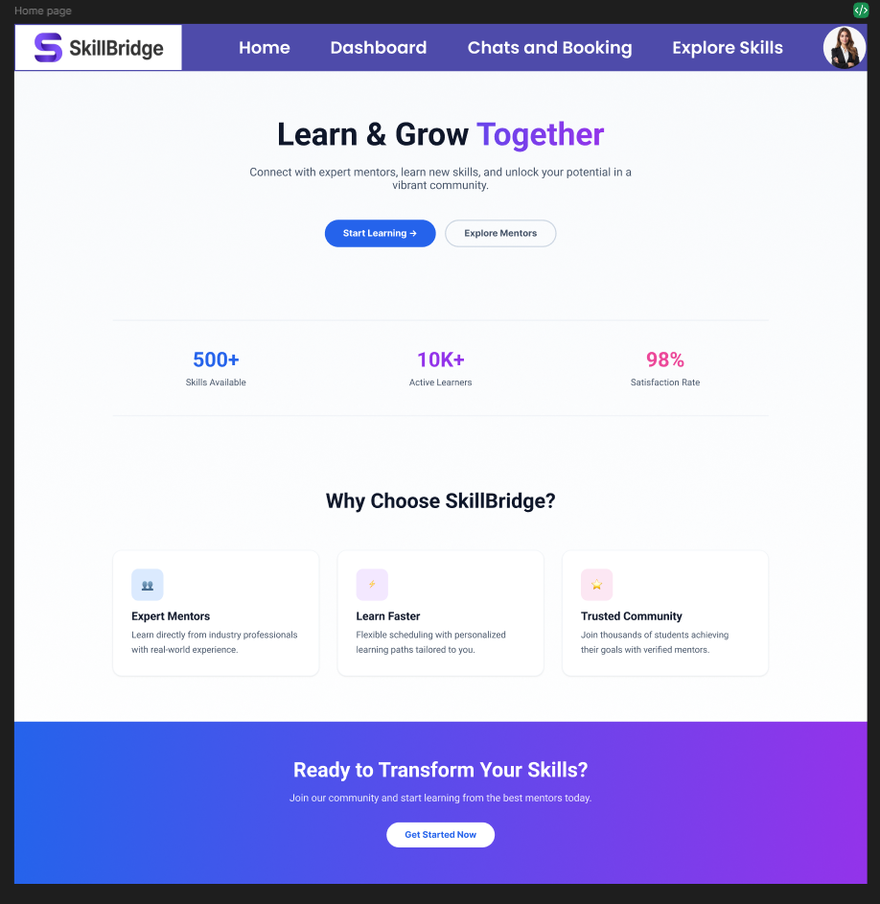
Figure 1: Home Page of SkillBridge showing platform introduction and featured skills.

Figure 2: Explore Skills Page
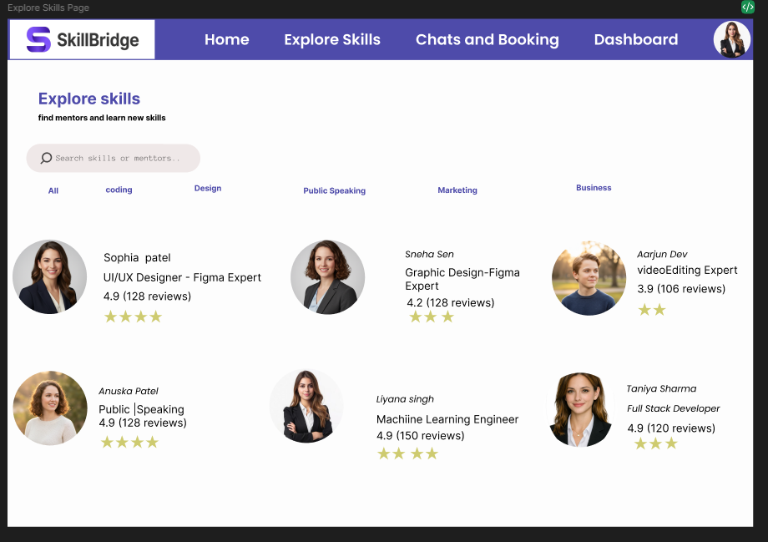
Figure 2: Explore Skills Page allowing users to search skills and discover mentors.

Figure 3: Mentor Profile Page
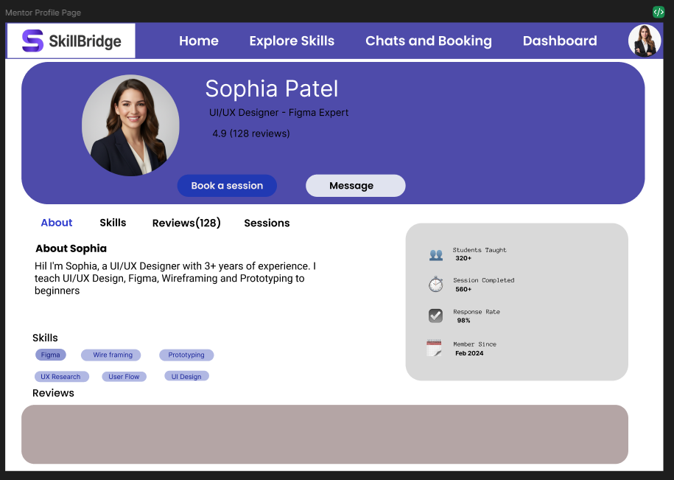
Figure 3: Mentor Profile displaying mentor details, ratings, and booking options.

Figure 4: Chat and Booking Page
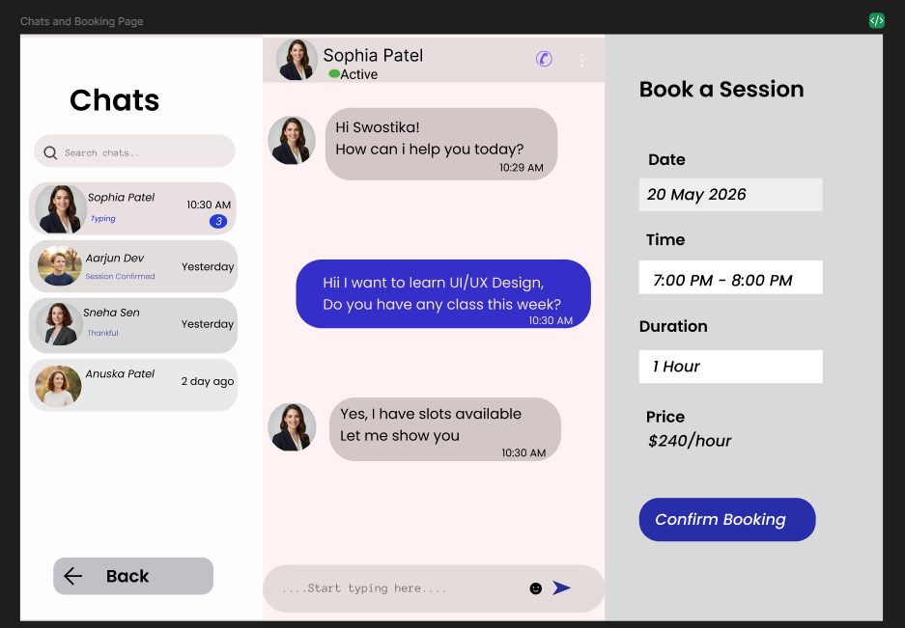
Figure 4: Chat and Booking Page supporting communication and session scheduling.

Figure 5: Dashboard
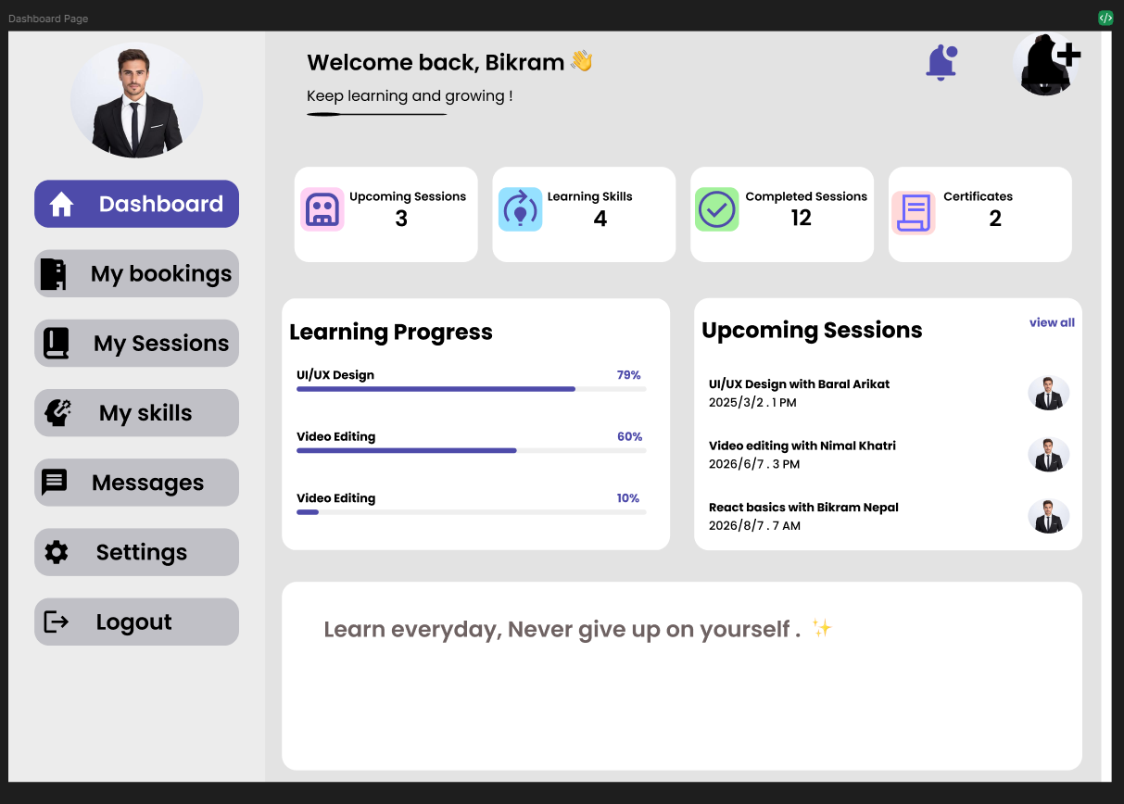
Figure 5: Dashboard displaying user activities and learning progress.

3.2 Implementation
Figma was the initial tool used to produce the design; then, the functional web application was developed from the high-fidelity prototype into a responsive website using HTML, CSS, JavaScript, Tailwind CSS and React.js. The completed website implements the approved UI/UX design and contains five primary navigation buttons/pages: Home Page, Explore Skills Page, Mentor Profile Page, Chat and Booking Page & Dashboard.

Table 3: Color Palette
Preview | Color | Hex Code | Purpose
 | Purple | #4E4BAA | Creativity and Learning
 | White | #FFFFFF | Clean Background
 | Dark Navy | #0F172A | Professional Appearance

Table 4: Typography
Font | Usage
Poppins | Headings
Archivo Black and Inter | Body Text

3.3 Testing and Analysis
A usability test of the high-fidelity prototype was performed to verify the usability, consistency, and navigability of the site. Testing focused on the user's overall experience with respect to usability, accessibility, visual hierarchy, and functional value.
Results from the usability testing indicated that users were able to navigate the pages of the website easily; locate and identify potential mentors; communicate through chat with potential mentors, and successfully complete the complete booking process. The clean user-interface and intuitive navigation support a positive overall user-experience.
Table 5: Prototype Testing Results
Test Case | Expected Outcome | Result
Navigate between pages | User can move easily between screens | Passed
Search mentors | Users can search mentors by skill | Passed
View mentor profile | Mentor details are displayed correctly | Passed
Book a session | Booking interface is easy to use | Passed
Dashboard access | Learning progress is displayed | Passed

According to our testing results, the site seems to be functioning as intended. Users were able to navigate seamlessly from one page to another, search for their mentors, read about their mentor's profiles, schedule appointments, and track their dashboard activities without experiencing any significant usability problems. In summary, we were successful in achieving the objectives of the project and have also maintained a consistent user experience throughout.

4. Tools and Technologies

4.1 Figma
Figma is the primary tool for creating wireframes, user interfaces, prototypes, and design systems. Figma makes collaboration between team members simple and allows for rapid design iterations.

4.2 HTML
HTML is the code behind the structure and content of the websites.

4.3 CSS
CSS provides the means to beautify a website by adding style elements to the design and keeping a consistent look throughout the UI.

4.4 JavaScript
JavaScript adds interactive components and gives a dynamic finish to the website.

4.5 Tailwind CSS
Tailwind CSS helps speed up the development process as well as provide a consistent component design.

4.6 React.js
React.js is used to create reusable components in a user interface and helps to improve the performance of the overall application.

5. CONCLUSION
SkillBridge is a student-centered skill exchange platform designed to promote collaborative learning through peer-to-peer knowledge sharing. The project was developed to address common challenges faced by students, including the high cost of online learning platforms, limited access to mentors, and the lack of a dedicated platform for student-to-student learning.
Through the application of modern UI/UX design principles, our team designed and developed a clean, user-friendly website that enables students to discover mentors, communicate through chat, book learning sessions, and monitor their learning activities. The interface focuses on simplicity, accessibility, consistency, and ease of navigation to provide a positive user experience.
Working on this project has also enhanced our understanding of the complete UI/UX design process, including user research, wireframing, prototyping, interface design, usability evaluation, and collaborative teamwork. Overall, SkillBridge demonstrates how thoughtful interface design can improve learning opportunities, encourage knowledge sharing, and build stronger student communities.

5.1 Limitations
Although the project successfully demonstrates the proposed solution, it has several limitations:
• The current version of the website does not include a backend database.
• User authentication and authorization features are limited.
• Real-time messaging functionality is not fully implemented.
• Payment integration is not available in the current version.
• The project has been tested on a limited number of users.
• Mobile responsiveness can be further improved.

5.2 Future Work
The project can be further enhanced by implementing additional features and technologies in future development. Possible improvements include:
• Integrate a backend database.
• Implement secure login and registration.
• Add real-time chat using WebSockets or Firebase.
• Integrate online payment gateway.
• Develop a mobile application.
• Add AI-based mentor recommendations.
• Improve accessibility features.
• Deploy the website on a live hosting platform.

REFERENCES
Figma. (2025). Figma documentation. https://www.figma.com/developers
Garrett, J. J. (2011). The elements of user experience: User-centered design for the web and beyond (2nd ed.). New Riders.
Krug, S. (2014). Don't make me think, revisited: A common sense approach to web usability (3rd ed.). New Riders.
Norman, D. A. (2013). The design of everyday things (Revised and expanded ed.). Basic Books.
React. (2025). React documentation. https://react.dev/
Tailwind Labs. (2025). Tailwind CSS documentation. https://tailwindcss.com/docs
W3Schools. (2025). CSS tutorial. https://www.w3schools.com/css/
W3Schools. (2025). HTML tutorial. https://www.w3schools.com/html/
W3Schools. (2025). JavaScript tutorial. https://www.w3schools.com/js/

APPENDIX

Appendix A: Low-Fidelity Wireframes
These are the first sets of wireframes that have low fidelity created in the initial design process for the SkillBridge platform to plan their layout, navigation, and user journey. The purpose of these wireframes is to allow the SkillBridge team to visualise what their interface would look like before they built the high-fidelity prototype in Figma.

Figure A.1: Low-Fidelity Wireframes of SkillBridge
The wireframes were utilized as a base for building the high-fidelity prototype of SkillBridge as well as the launch of the final SkillBridge website.
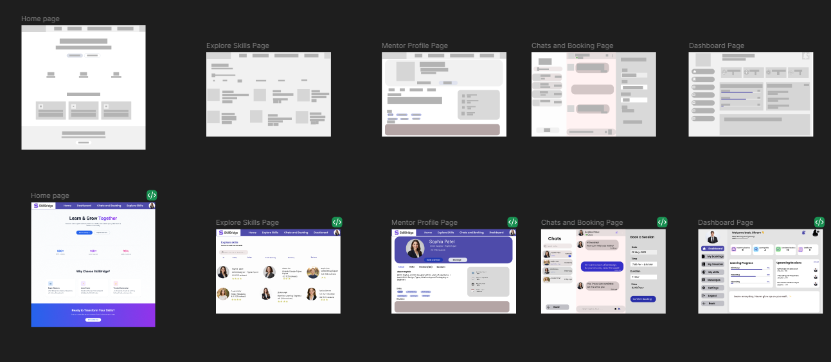Description:
The wireframes depict the initial designs/layout for the five main pages the SkillBridge platform will have:
- Home Page
- Explore Skills Page
- Mentor Profile Page
- Chat & Booking Page
- Dashboard
Once all the wireframes are created, the SkillBridge team will be finalizing the designs into high-fidelity User Interface (UI) designs while maintaining consistency in navigation and user experience.

Appendix B: Team Contribution
Team Member | Responsibility
Srijana Adhikari | UI/UX Design – Home Page and Explore Skills Page
Swostika Adhikari | UI/UX Design – Mentor Profile Page and Chat & Booking Page
Bikram Poudel | UI/UX Design – Dashboard and Complete Website Development
All Members | Research, Documentation, Testing, Presentation, and Final Review

The project was completed through collaborative planning, regular discussions, and continuous feedback among all team members.

